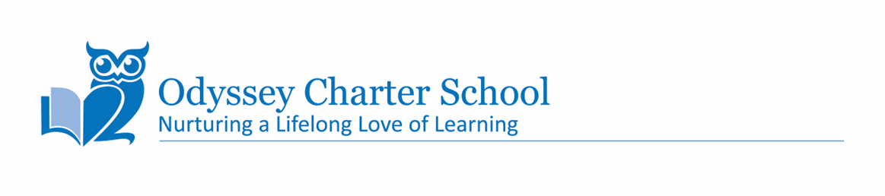
INCOME ELIGIBILITY GUIDELINES FOR FREE AND REDUCED-PRICE MEALS

Effective Date: July 1, 2026 - June 30, 2027

These are the income scales used by Child Nutrition Programs to determine eligibility for free and reduced-price meals.

Free Meals – 130% |  |  |  |  |  | Reduced Meals – 185%
Household Size | Yearly | Monthly | Twice  per  Month | Every two weeks | Weekly | Yearly | Monthly | Twice  per  Month | Every two weeks | Weekly
1 | $20,748 | $1,729 | $865 | $798 | $399 | $29,526 | $2,461 | $1,231 | $1,136 | $568
2 | $28,132 | $2,345 | $1,173 | $1,082 | $541 | $40,034 | $3,337 | $1,669 | $1,540 | $770
3 | $35,516 | $2,960 | $1,480 | $1,366 | $683 | $50,542 | $4,212 | $2,106 | $1,944 | $972
4 | $42,900 | $3,575 | $1,788 | $1,650 | $825 | $61,050 | $5,088 | $2,544 | $2,349 | $1,175
5 | $50,284 | $4,191 | $2,096 | $1,934 | $967 | $71,558 | $5,964 | $2,982 | $2,753 | $1,377
6 | $57,668 | $4,806 | $2,403 | $2,218 | $1,109 | $82,066 | $6,839 | $3,420 | $3,157 | $1,579
7 | $65,052 | $5,421 | $2,711 | $2,502 | $1,251 | $92,574 | $7,715 | $3,858 | $3,561 | $1,781
8 | $72,436 | $6,037 | $3,019 | $2,786 | $1,393 | $103,082 | $8,591 | $4,296 | $3,965 | $1,983
For each additional household member, add: | $7,384 | $616 | $308 | $284 | $142 | $10,508 | $876 | $438 | $405 | $203

